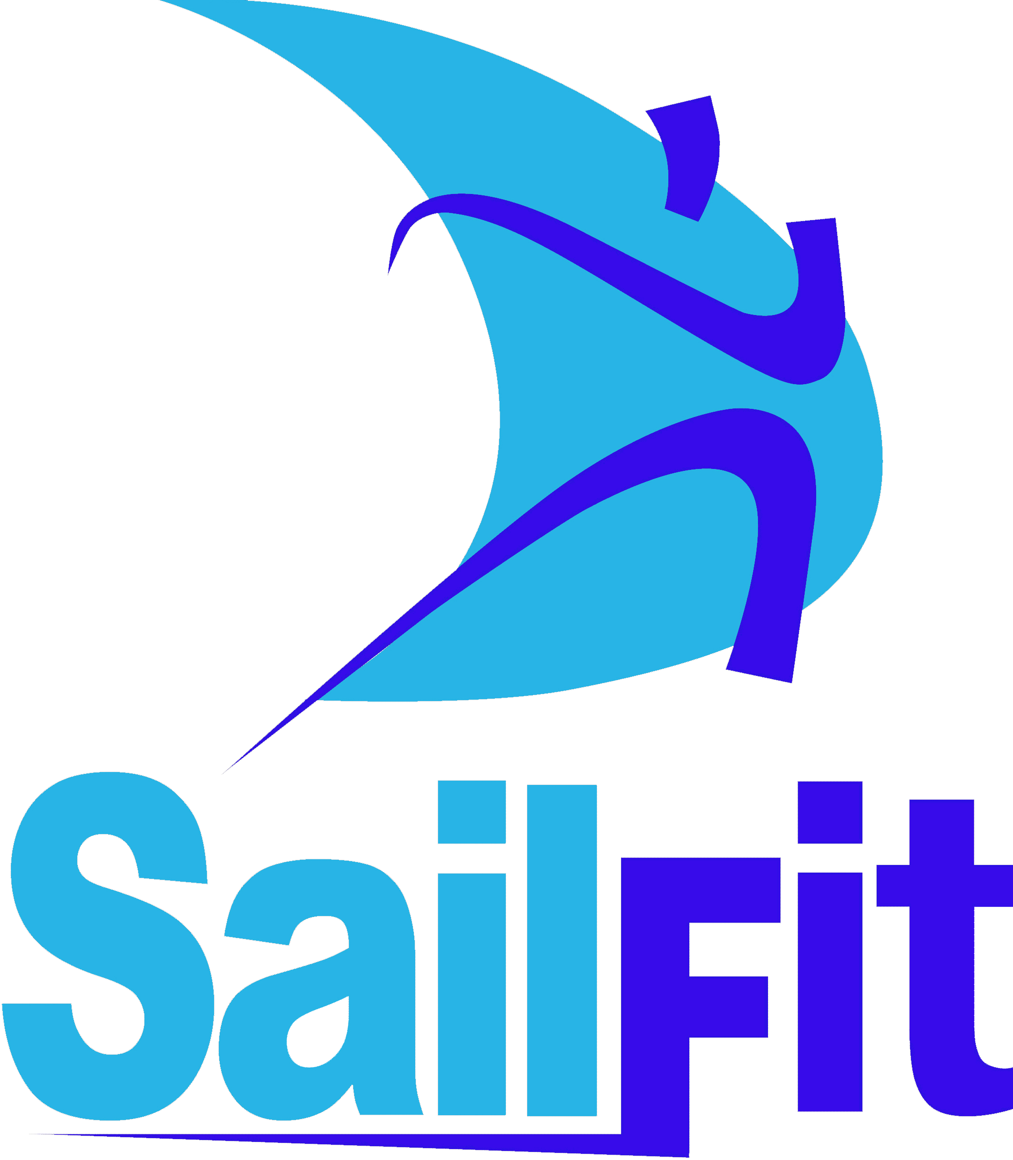
SailFit COACHING SERVICES LIABILITY WAIVER
Sailing is an activity that has an inherent risk of damage and injury. Sailors
receiving coaching services participate entirely at their own risk. SAILFIT and its employees and volunteers will not be responsible for damage to any boat or other property or the injury or death to any participant sustained as a result of participation in any services by SAILFIT and its employees and volunteers. I understand that the decision to go afloat is entirely my own.
To the fullest extent permitted by law, I hereby waive any rights I may have to sue Kurt Taulbee or Meka Taulbee or SAILFIT Incorporated or its employees or volunteers involved with coaching services, with respect to personal injury or property damage suffered by myself as a result of participation in sailing lessons, sailing clinics, sailing seminars, sailing team practice, regatta coaching, fitness training or any other services, and I hereby release Kurt Taulbee and Meka Taulbee and SAILFIT Incorporated and its employees and volunteers from any liability for such injury or damage.

I have read and fully understand the above statements and I voluntarily agree to these terms and conditions.

_____________________________________
Printed Name of Participant

______________________________________
Participant Signature (Parent if under 18) Date

_______________________________________
Printed name of parent if under 18
Photo and Video release
In connection with my participation in SAILFIT Coaching Services, I consent to the use of my photograph and video in promotional or other materials and products of SAILFIT without payment or other consideration made to me.

____________________________
Participant Signature (Parent if under 18) Date

